GOOD CHOICE COLLEGE SCHOOL
END OF TERM I EXAMINATION
S.6 BIOLOGY PAPER 2
INSTRUCTIONS: Question one is compulsory
Choose any three questions from section B
Time: 2:30 hours
Section A
1. In an experiment, the rate of uptake of glucose by the blood using simple and facilitated diffusion at varying extracellular concentration of glucose was measured. The results are shown in figure One. Study the information and answer questions that follow.
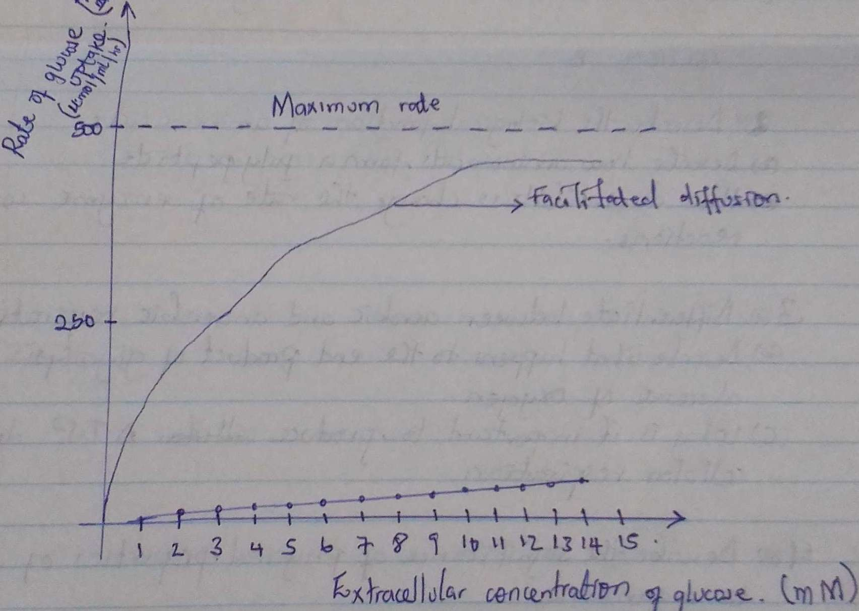
a). Describe the rate of glucose uptake with increasing extracellular concentration when diffusion is facilitated. (9 marks)

b). Compare the rate of glucose uptake when diffusion is facilitated and when it's not. (8 marks)

c). Explain the effect of increasing extracellular concentration of glucose when diffusion is facilitated. (8 marks)

d). Suggest what would happen to the rate of glucose if a respiratory poison was introduced into the cell membrane. (6 marks)

e). Explain why;
I). Facilitated diffusion occurs (6 marks)
Il). The cell membrane is able to carry out facilitated diffusion. (3 marks)

SECTION B

2(a). Differentiate between aerobic respiration and anaerobic respiration. (5marks)
b). Describe what happens to the end product of glycolysis in absence of oxygen. (10 marks)
c). Why is it important to produce ATP during cellular respiration? (5 marks)

3(a). How does each of the following explains the movement of water and mineral salts up the xylem?
I). Cohesion and tension theory. (6 marks)
Il). Root pressure. (5 marks)
b). Describe the characteristics of open and closed circulatory system. (9 marks)

4(a)I. Discuss the factors that affect the rate of diffusion at a respiratory surface.(6marks)
II). How are the conditions for efficient gaseous exchange fulfilled in mammalian lungs? (8 marks)
b). The diameter of capillaries is smaller than the diameter of red blood cells passing through them. How does this relationship help in gaseous exchange in lungs. (06marks)

5(a). Describe the structure of the vascular system in plants. (7 marks)
b). How is the system in (a) adapted to its function? (13 marks)

6. (a) I. Describe the structure of haemoglobin molecule. (4 marks)
II). Explain why the affinity of haemoglobin for oxygen increases when it already posses oxygen. (3 marks)
b). Describe how the PH of blood and tissue fluids in mammals is maintained. (13 marks)

